Nama: Richard Tandryan
Kelas: TI-26-PA2
NPM: 2620310019
Github: https://github.com/ThegamesXD23/LabAlgoritmaTI26PA2_Richard_Tandryan_2620310019_Semester_1.git

Output Kode:
Char

Int
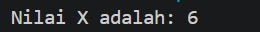

Float

Double

String

Output Nama dan NPM
